Noël Coward

Daniel Vince.

Sir Noël Peirce Coward (1899-1973) was born in Teddington, south-west London, on December 16th, 1899. His father, Arthur Coward was a piano salesman for Metzlers and his mother, Violet, frequented the local theatres. From the age of four, he sang and performed in school concerts and productions; six years later, Coward had his first professional performance, appearing in children’s musical play _*The Goldfish_* and had great success in his role as Prince Mussel. Many childhood performances followed and kicked off his career in show business. Juvenile performances included parts in _*Where the Rainbow Ends_* in 1911 and in 1912, Coward had his directorial debut, bringing _*The Daisy Chain_* to the Savoy Theatre, London.

Coward’s career as a director, writer and actor continued to flourish throughout the first and second decades of the twentieth century. After returning from a visit to America and his success with _*A Withered Nosegay_* (1922), Coward spent his first days in Kent, staying first at Dymchurch with friend Gladys Calthrop. After several weeks exploring Romney Marsh in search of a more permanent residence, the pair found a cottage next to the Star Inn at St. Mary in the Marsh where he became acquainted with [Edith Nesbit](/nesbit/nesbit-biography), the author of _*The Railway Children_*. Four years later, he re-located to Goldenhurst Farm near Aldington. Goldenhurst Farm would remain his beloved country retreat for the two following decades. Whilst at Goldenhurst Farm, Coward would produce two key works of his early years: _*The Vortex*_(1924), and _*Bitter Sweet_* (1929). By the break of the 1930s, Coward was well established as a theatrical celebrity and continued to write for many decades to come and. He later toured the Far East where he continued to write notable works such as _*Private Lives_* (1930) and _*Post-Mortem_* (1930).

The following decade sees Coward take-off into stardom as his work circulates the globe, with his plays frequenting the theatres of New York, London and Paris. At the break of war in 1939, Coward takes on several roles, the primary roles being in propaganda work for the Ministry of Information and his performing of patriotic, propagandistic plays. Coward’s participation in the ‘Phoney War’ of propaganda led to tours of Australia and New Zealand, whilst acquiring funding for war charities.

Goldenhurst Farm was requisitioned by the army and at the end of the war, Coward leased White Cliffs in St. Margaret’s from the Hon. Kay Norton and would remain there for seven years. In 1945, Coward wrote in his diary: ‘Another perfect day at White Cliffs. I don’t think I can fail to be happy there’. White Cliffs required a great deal of renovation, as during the Second World War, it was used by British and Canadian troops as a training area for D-day. It was one of four houses at the end of St. Margaret’s beach and was to be extended in the latter half of the 1940s. Coward purchased the remaining three houses, inviting various family members to take residence and establishing a small familial estate on the Kentish coast. Visitors included Daphne du Maurier, Katherine Hepburn, Ian Fleming and Graham Payn. Guests would pay visits to local attractions in [Deal](/seascape/deal), Dover and Folkestone. During his seven year stay at White Cliffs, Coward worked on numerous plays and short stories, none of which achieved the praise of his pre-war work. In 1951, Coward decided to leave his “happy house”, White Cliffs, for lack of privacy and lack of inspiration. He immediately relocated to his Romney Marsh home.

His friendship with Ian Fleming began when Coward started leasing Fleming’s Jamaican residence, Goldeneye, in 1948; they instantly became friends and great deal of time together in the following years. Coward built a place for himself in the Caribbean and would spend many happy years frequenting his foreign estate, Firefly; he would never again reside in his native country. Coward would be knighted in the 1970 New Year’s Honours List and began his retirement at his home in Jamaica. In 1973, Sir Noël Peirce Coward passed away peacefully at Firefly and is buried on Firefly Hill.

Works Cited

Coward, Noel, and Graham Payn. _*The Noël Coward Diaries_*. 1st ed., Da Capo Press, 2000.

[‘Noel Coward | Biography, Plays, & Facts’](<https://www.britannica.com/biography/Noel-Coward>]. _*Encyclopedia Britannica_*, 2021.

Hoare, Philip. _*Noël Coward: A Biography_*. 1st ed., Sinclair-Stevenson, 1995.

Photographs are arranged to be shown in this order and sources are listed below-

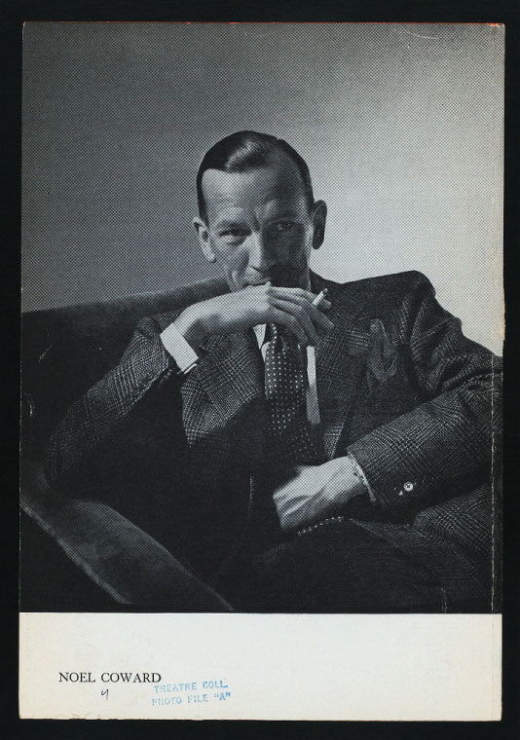

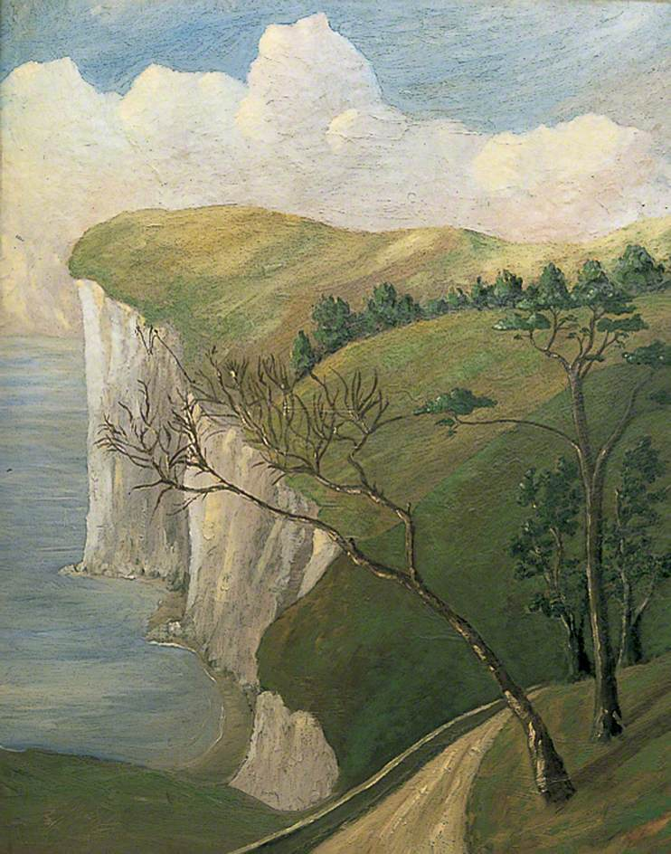

1. Public Domain (https://commons.wikimedia.org/wiki/File:Noel_Coward_in_his_teens.jpg)
2. Public Domain (https://digitalcollections.nypl.org/items/510d47de-b974-a3d9-e040-e00a18064a99)
3. Taken by myself
4. Pending Permission from Dover Museum